CHILD PROGRESS TRACKER
@CREATIVITY THINK (9483175986/7019689991)

ABSTRACT:
Child Progress Tracker is a web-based application designed to monitor, log, and visualize the development of children in schools and daycare centers. The system allows educators to record skills, track progress, provide feedback, and present data through graphical dashboards for parents and administrators. Users can update child profiles, view progress charts, and share feedback, while administrators oversee entries, moderate content, and analyze performance using dashboard analytics. Built with Django and Django Rest Framework for the backend and React with axios and recharts for the frontend, the platform ensures accurate progress tracking, transparent reporting, and efficient management of child development data..

INTRODUCTION OF THE PROJECT:
Monitoring child development is critical for parents, educators, and administrators to ensure timely interventions and growth tracking. Traditional methods involving paper-based records or unstructured spreadsheets are inefficient and error-prone. Child Progress Tracker provides a centralized, digital platform to log skills, track milestones, offer feedback, and present visual insights. With automated reporting, role-based access, and interactive dashboards, the system simplifies communication between educators and parents while maintaining accurate and up-to-date records..

PROJECT OBJECTIVES:

• Provide a centralized system to log and track child skills and progress
• Enable educators to update records and provide detailed feedback
• Generate visual dashboards and charts for clear performance insights
• Allow parents to view child development progress efficiently
• Enable administrators to moderate entries and feedback
• Provide analytics tools for monitoring trends and performance
• Ensure data accuracy, security, and role-based access control
• Streamline communication between parents, educators, and administrators

PROBLEM OF THE STATEMENT:
Traditional tracking of child progress relies on manual entries, fragmented reporting, and lack of transparency, making it difficult for parents and administrators to access timely information. Educators face challenges in maintaining consistent records and providing structured feedback. Child Progress Tracker solves these issues by offering a centralized platform with logging, feedback, and analytics capabilities, ensuring accurate, accessible, and actionable insights for all stakeholders..

MOTIVATION OF THE PROJECT:
• To digitalize child development tracking for schools and daycares
• To provide real-time access to progress and feedback for parents
• To reduce manual record-keeping and minimize errors
• To allow administrators to oversee data integrity and analytics
• To support educators with a structured and user-friendly interface
• To enhance communication and accountability between educators and parents
• To provide visual insights for better decision-making regarding child growth

BLOCK DAIGRAM OF PROJECT:

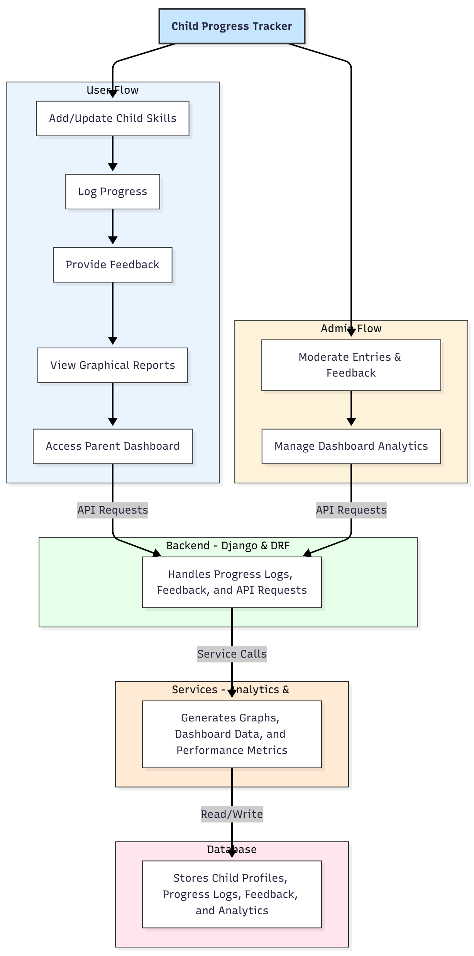

WORKING OF THE PROJECT:
Educators begin by adding and updating child skills, logging progress, and providing feedback through the system. Each entry is validated and stored in the backend securely. Users can view graphical reports of progress and access a parent dashboard for detailed insights. Administrators monitor entries, moderate feedback, and analyze overall performance trends through the dashboard. The services module generates charts, performance metrics, and analytics. All data is securely stored in the database, ensuring accurate reporting, transparency, and smooth communication between educators and parents..

SOFTWARE REQUIREMENT:
- Backend:
  - Python 3.x
  - Django
  - Django REST Framework
  - SQLite/PostgreSQL
- Frontend:
  - Node.js and npm
  - React.js
  - Axios
- Development Tools:
  - Visual Studio Code
  - Postman (for testing APIs)
  - Git/GitHub (for version control)
- Server/Deployment (Optional):
  - Gunicorn, Nginx, or Heroku/AWS for hosting

ADVANTAGES OF THE PROJECT:

• Centralized child progress tracking system
• Accurate logging and feedback mechanism
• Graphical dashboards for clear insights
• Parent-friendly reporting interface
• Administrative moderation and analytics
• Reduces manual record-keeping errors
• Enhances educator-parent communication
• Scalable for schools and daycare centers

APPLICATIONS OF THE PROJECT:
• Schools and educational institutions
• Daycare centers
• Parents tracking child development
• Special programs and extracurricular activities
• Early learning and skill development tracking

REFERENCES:

- Django REST Framework Documentation — Django Software Foundation. Django Documentation. Available: https://docs.djangoproject.com/
- Django REST Framework. DRF Documentation. Available: https://www.django-rest-framework.org/
- React. React Official Documentation. Available: https://reactjs.org/docs/getting-started.html
- Redux. Redux Documentation. Available: https://redux.js.org/introduction/getting-started
- PostgreSQL Global Development Group. PostgreSQL Documentation. Available: https://www.postgresql.org/docs/
- MySQL. MySQL Reference Manual. Available: https://dev.mysql.com/doc/
- Git. Git Documentation. Available: https://git-scm.com/doc
- Node.js. Node.js Documentation. Available: https://nodejs.org/en/docs/
- Axios. Axios Documentation. Available: https://axios-http.com/docs/intro
- Socket.io Documentation – https://socket.io/docs/

